Tell me about yourself 🡪 after 8 year of experience in service based industries, I thought to change from service based to product based so I started learning DSA, so I started working on it, then somehow I got to know about FAANG company, so started consuming as much as I can, started learning as much as I can, started solving question Leetcode, over sudden I started writing blog post and started contributed in OPEN source, because of that I become better coder day by day and now I feel very confident and being able to valuable assets to your team.

WHY Us 🡪 make the interviewer to feel special, and show them how you are admiring to this company, remember interview is for stand out from other, not the showing what other is doing, you have to show how good you are. 1> Show them you want to grow Demo 2> Demonstrate why you are the best. 3> but remember don’t tell anything wrong about your previous company and negative comment.

Any Question for me 🡪 1> Focus on them, no company(you). 2> Mention something they mentioned

1. What the greatest mistake that you have done in your job in first month.
2. Where do you see this company going in next 3 year, you are already here, you know better than anybody else.
3. Why did you join this company.
4. What they were then when they just started just company. (these are the just way to talk with them after the interview.)

Challenged faced in work

1. Worked in a very short time – once project delivery time was decided 31 December 2020 but client changed this date to 15 December 2020 because all the onsite (US) people will go on vacation, this news we got in approx. in September mid or October, now in every sprint whatever story point PO is deciding apart from that taking more story from backlog most probability small story, started making question on that if any. And try to finish new story in current sprint.
2. All the story get finished on 11th December 2020, but last 2 sprint deployment happen after 1st Jan 2021, and there is 2 changes in database (updating new client for new clinic branches), and we did this, and production bug get fixed.

Supply Service architecture

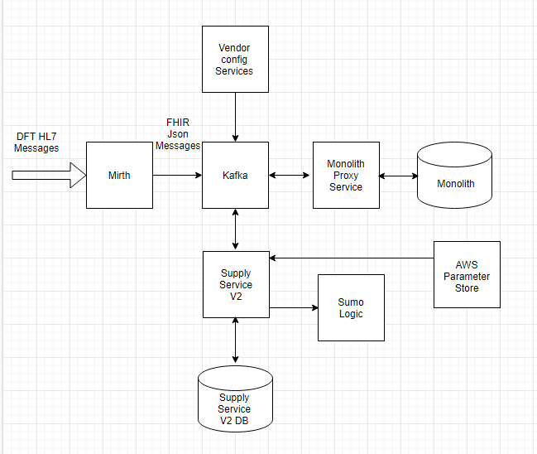

1. Mirth

* Receiving a DFT (Detailed Financial Transaction) HL7 format message from Mirth.
* Transform HL7 to FHIR (Fast Healthcare Interoperability Resources) Json Messages.
* Publish FHIR messages to Kafka topic.

1. Supply Service V2.

* Receive DFT messages from Kafka on *InboundDFTFHIRRequest* topic.
* Validate & Parse FHIR Json message using *HHH.PLT.FHIR.Profiles.R4.*
* Once R4 Validation done than it undergoes and Custom Validation ItemNumber, Account, TransactionDate, InvoiceId & Quantity.
* Validate DFT against Vendor Configuration.
* Store each bundle in FHIR Json Message and each charge item in supply Invoice table.
* And sending process DFT to MonolitProxy.

1. Monolith

* Now Monolith is database that UI is using it.
* From here User can see what supply is coming and what is details.